**Activity 19**

**NAME : Abinaya COURSE: MOBILE COMPUTING**

**REG NO : 192421208**

**COURSE CODE: ITA0302**

Develop a user interface prototype for an Android application using Figma.

**Aim:**

To Develop a user interface prototype for an Android application using Figma.

**Procedure:**

1. Create a file

2. Add The First Frame

3. Add Shapes

4. Add Text

5. Create The Second Frame

6. Add Prototyping

Step By Step Procedure :

Interface Of Experiment:

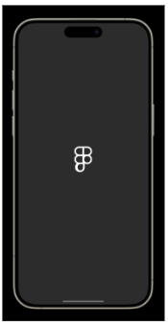

Next Page:

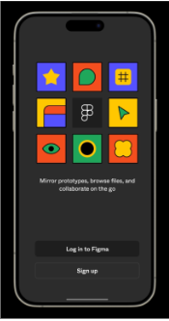

Login And Signup Page:

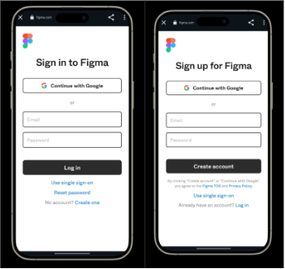

Final Step:

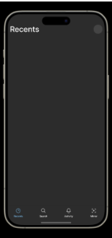

Prototype:

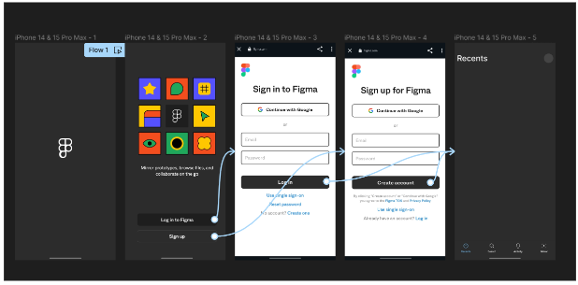

**Result:**

Hence the Develop a user interface prototype for an Android application created and executed successfully